MATER DEI COLLEGE

YEAR 11 HUMAN BIOLOGY D406

THE HUMAN LIFECYCLE

INFANCY, CHILDHOOD, ADOLESCENCE AND SENESCENCE

SECTION A: MULTIPLE CHICE 25 marks

1. New born infants have
- a high mass to surface area ratio
- an equal surface area to mass ratio
- a high surface area to mass ratio
- a high weight ratio to mass

2. New born infants have difficulty maintaining all of the following functions except
one. Choose the incorrect answer.
- maintaining body temperature
- maintaining water balance
- maintaining oxygen requirements
- maintaining metabolic rate

3. The cephalocaudal pattern of a child development suggests that;
- growth and development appear first close to the centre of the body
- greatest growth always occurs first at the top region of a child's body
- newborn reflexes disappear soon after birth
- a baby's hearing develops before eyesight

QUESTIONS 4 & 5 REFER TO THE GRAPH BELOW

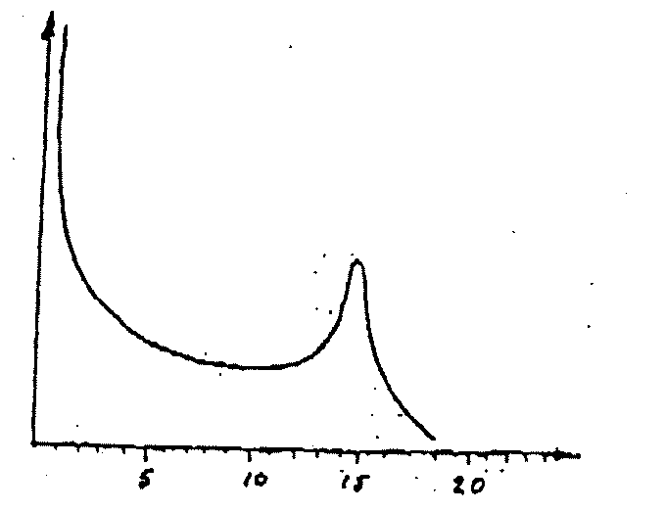

4. The boy's maximum growth rate occurred during
- 4 - 6 years
- 0 -2 years
- 10 - 12 years
- 14 - 16 years

5. A similar graph drawn of the average height gain of girls between the ages of 8 -
20 years would most likely be;
- to the right of the graph for boys
- to the left of the graph for the boys
- above the graph for the boys
- impossible to tell

6. Milk - let down is due to the action of which hormone?
- prolactin
- oxytocin
- prostaglandins
- oestrogen

7. Which sequence of development is the most likely to humans?
- grasps and shakes objects; eats unaided; picks up objects between thumb and forefinger.
- grasps and shakes objects; picks up objects between thumb and forefinger;
walks.
- eats unaided; grasps and shakes objects; picks up objects between thumb
and forefinger; walks
- eats unaided; grasps and shakes objects; picks up objects between thumb and forefinger.

THE DIAGRAM BELOW SHOWS A MALE FOETUS, NEW - BORN BABY, BOY AND A MAN.

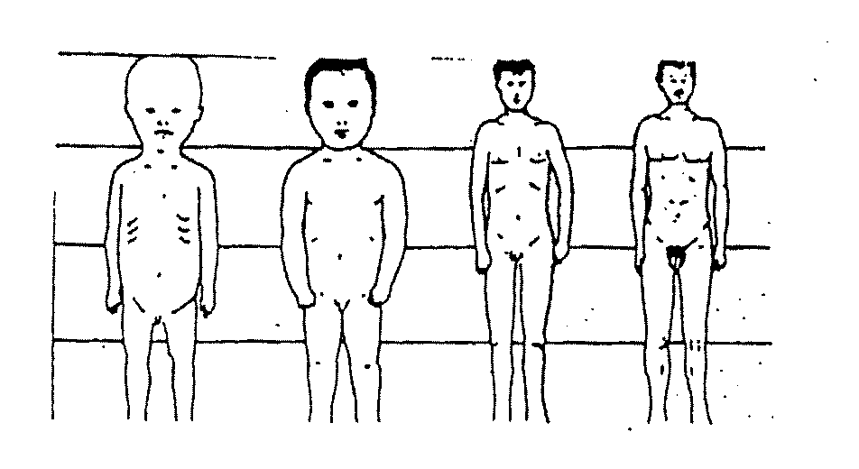

8. What is the best explanation of the changes shown?
- the head becomes smaller
- different parts of the body grow at different rates
- men are stronger than babies
- the legs increase in length but the rest of the body does not.

9. Which of the following are secondary sexual characteristics of the human female?
i) development of the ovaries
ii) hairs growing around the genitalia
iii) voice changes to become deeper
iv) broadening of the pelvic girdle
v) breast development

- i and v only
- ii and iv only
- i, iii, and v only
- ii, iii, iv, and v only

10. Which of the following hormones causes development of secondary sexual
characteristics in males?
- follicle stimulating hormone
- oestrogen
- testosterone
- Luteinizing hormone

11. The development of secondary sexual characteristics and reproductive functions; the completion of a basic education; and a trend towards adult appearance and behaviour, tend to be characteristic of the period of;
- early adulthood
- puberty
- primary schooling
- late adolescence

12. Menarche is the
- end of the fertile period in women
- onset of puberty in girls
- onset of menstruation in girls
- rapid growth at puberty

13. The process of aging is NOT necessarily made evident by;
- increasing fragility of bone
- calcification of cartilage
- atrophy of intervertebral discs
- loss of potential of usefulness

14. The term menopause refers to:
- cessation of ovulation and menstruation
- time of emotional disturbance in all women
- a dramatic rise in the level of circulating oestrogen
- a change in the lifestyle of a women aged 45

15. The main indicator of physical maturity is:
(a) the growth of pubic hair (b) breast development
(c) ability to reproduce (d) hairs growing on the chest

16. Following the completion of growth, which of the following occurs:
(a) gradual compression of the spine (b) joint wear
(c) failing eyesight (d) all of the above

17. The major cause of death in youth is:
(a) heart attack (b) cancer
(c) accidents (d) suicide

18. Menopause occurs at age;
(a) 35 (b) 40
(c) 55-60 (d) 45-50

19. Senescence begins at age:
(a) birth (b) 13 - 20 (c) adulthood (d) 45 – 50
20. The major physical change/s in aged people is:
(a) loss of collagen (b) loss of protein in the muscles
(c) wrinkling (d) all of the above

21. Osteoporosis is caused by a depletion of:
(a) iron (b) vitamins (c) calcium (d) all of those

22. Puberty lasts for approximately:
(a) 1 year (b) 5 years 12 - 17 (c) 7 years 13 - 20
(d) 3 years

23. The normal child will begin to walk at
- 2 years
- 15 months
- 3 months
- 2 ½ years

THE FOLLOWG DATA REFERS TO QUESTION 24
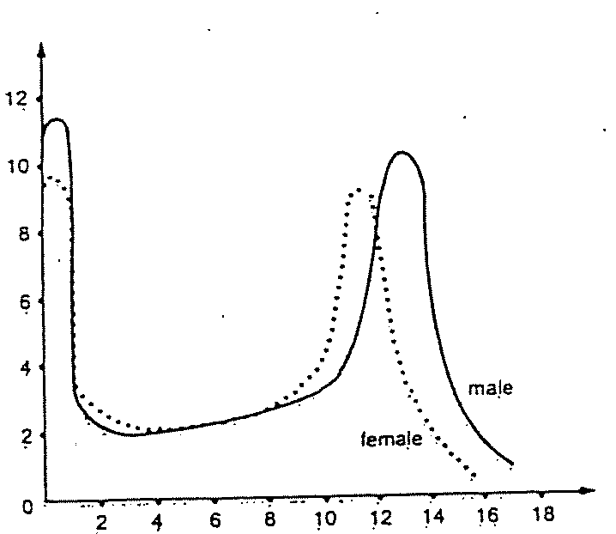

24. From the data above, which of the following statements can be deducted?
- All boys have their greatest period of adolescent growth later than all girls.
- Some boys have their greatest period of adolescent growth earlier than all girls.
- The average boy achieves greatest weight gain later than the average girl during adolescence.
- From age 14 onwards, most boys and girls lose weight.

25. The graph below shows the weight of various tissues of the human body ( as a
percentage of the final weight of the organ in the adult ) as an individual develops from birth to maturity (age 20).

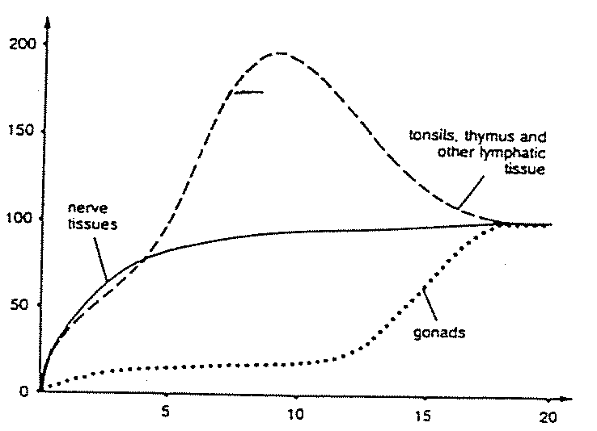

From this information, which of the following cannot be concluded?
- Soon after birth the nervous system grows most rapidly.
- By about 10 years of age the tonsils and thymus gland reach maximum size, and then grow smaller again.
- At about 20 years of age all the above tissues are approximately the same weight.
- The gonads start to develop rapidly at a later stage than the other organs shown.

NAME: ___________________________ | TEACHER: ________________________
 | Mark: _______________/ 55

YEAR 11 HUMAN BIOLOGY D406
INFANCY, CHILDHOOD, ADOLESCENCE AND SENESCENCE.
ANSWER BOOKLET

Place a cross (X) over the best answer.

1 | A | B | C | D
2 | A | B | C | D
3 | A | B | C | D
4 | A | B | C | D
5 | A | B | C | D
6 | A | B | C | D
7 | A | B | C | D
8 | A | B | C | D
9 | A | B | C | D
10 | A | B | C | D
11 | A | B | C | D
12 | A | B | C | D
13 | A | B | C | D
14 | A | B | C | D
15 | A | B | C | D
16 | A | B | C | D
17 | A | B | C | D
18 | A | B | C | D
19 | A | B | C | D
20 | A | B | C | D
21 | A | B | C | D
22 | A | B | C | D
23 | A | B | C | D
24 | A | B | C | D
25 | A | B | C | D
 |  |  |  | /25

SECTION B: SHORT ANSWER ( 30 marks )

1. List four advantages of breast feeding has over bottle feeding new born babies

- __________________________________________________________________

- __________________________________________________________________

- __________________________________________________________________

- __________________________________________________________________
( 4 marks )

2. a) Explain the term “senescence”.

________________________________________________________________________________________________________________________________________________________________________________________________________________________________________________ ( 1 mark )

- Discuss the changes which occur in two of the body's systems with senescence.

______________________________________________________________________________________________________________________________________________________________________________________________________________________________________________________________________________________________________________________________________________________________________________________________________________________________________________________________________________________________________________________________________________________________________________________________________________________________________________________

( 4 marks )

- Explain the difference between a hospice and a hospital.

______________________________________________________________________________________________________________________________________________________________________________________________________________________________________________________________________________________________________________________
( 2 marks )

3. a) Explain what is meant by the term socialisation.
________________________________________________________________________________________________________________________
( 1 mark )

- List the four factors which affect a child's early social behaviour.

1._____________________________________________________________________________________________________________________
2.______________________________________________________________________________________________________________________
3.______________________________________________________________________________________________________________________
4.______________________________________________________________________________________________________________________
( 4 marks )

4. Discuss two social problems with which the aged in our society must cope.

______________________________________________________________________________________________________________________________________________________________________________________________________________________________________________________________________________________________________________________________________________________________________________________________________________________________________________________________________________________________________________________________________________________________________________________________________________________________________________________
( 4 marks )

5. Explain:
- why blood pressure tends to increase with age.

____________________________________________________________________________________________________________________________________
(2 marks )

- why are elevated blood pressure levels such a concern

____________________________________________________________________________________________________________________________________
(2 marks)

6. a) Plot the following data on graph paper (provided). (4 marks)

Height Of Males 6 to 18 Years.
Age (years) | 6 | 7 | 8 | 9 | 10 | 11 | 12 | 13 | 14 | 15 | 16 | 17 | 18
Mean Height (cm) | 114.9 | 120.8 | 126.7 | 132.0 | 136.8 | 141.3 | 146.8 | 153.8 | 159.9 | 166.2 | 170.8 | 173.3 | 173.8

- Considering the graph you plotted, compared to other primates humans are not capable of having children to a much later age. Why is this the case?

______________________________________________________________________________________________________________________________________________________________________________________________________
(2 marks)

----- End of Test -----

NAME: ___________________________ | TEACHER: Answers 2006
 | Mark: _______________/ 55

YEAR 11 HUMAN BIOLOGY D406
INFANCY, CHILDHOOD, ADOLESCENCE AND SENESCENCE.
ANSWER BOOKLET

Place a cross (X) over the best answer.

1 | A | B |  | D
2 | A | B |  | D
3 | A |  | C | D
4 | A |  | C | D
5 | A |  | C | D
6 | A |  | C | D
7 | A |  | C | D
8 | A |  | C | D
9 | A | B | C
10 | A | B |  | D
11 | A | B | C
12 |  | B | C | D
13 | A | B | C
14 |  | B | C | D
15 | A | B |  | D
16 | A | B | C
17 | A | B |  | D
18 | A | B | C
19 | A | B |  | D
20 | A | B | C
21 | A | B |  | D
22 | A |  | C | D
23 | A |  | C | D
24 | A | B |  | D
25 | A |  | C | D
 |  |  |  | /25

